*AN AWARD WINNER INTERNATIONAL ORGANIZATION*

a Im



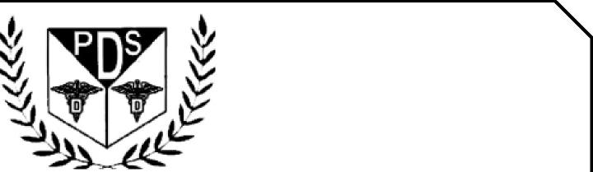

PROMOTING EXCELLENCE IN DENTAL EDUCATION   
Over 7000 Members Strong

**Presents**

A Must attend seminar for you and your staff

ORAL SURGERY FOR GENERAL DENTIST

**BY**

**DR HARDEV SINGH DMD**

**CARNIVAL CRUISE LINE**



**On   
JULY 5TH , 2025 (Sunday) 8:00 am till 12:00 am   
(CA Board 4 hrs C.E. units)   
at**

(Please print in capital letters or attach your business card)

Name DR/RDH/RDA/DA Lic no

|  |  |  |  |
| --- | --- | --- | --- |
| Circle one First Middle Initial Last | |  |  |
| Address |  |  |  |

City State Zip

Cell no ______________ Accept text message yes/no E-Mail________________________________________

**ARE YOU A PDS MEMBER: YES/ NO**

|  |  |  |
| --- | --- | --- |
| REGISTRATION FEE |  |  |
| Dentists Non-members | $50.00 |  |
| Members | $40.00 |  |
| Hygienist/R.D.A. Non-members | $40.00 |  |
| Members | $35.00 |  |

FOR REGISTRATION

CALL TOLL FREE 1-866-422-5573 (1-866-4-CALL-PDS) OR 909-933-9076   
**TO REGISTER ONLINE VISIT US ON WWW** [**PDSOCIETY. COM**](http://PDSOCIETY.COM)

Make check payable to

Dr. R. Salwan

President



PDS

124 EAST F STREET SUITE #8 ONTARIO, CA 91764

Dr. D.P. Singh Nagra

Chairman



**Webinar Date & Time:**

Sunday, JULY 4TH , 2025, 8:00 AM – 12:00 AM Pacific Time (US & Canada)

**Duration: 4 Hours**

**Course Description:**

**Course Description:**

**Oral Surgery for the General Dentist**

Exodontia can be both challenging and rewarding at the same time. It is critical for the practitioner to be able to have the correct armamentarium needed for their procedures and to be able to identify what conditions can make an extraction difficult. It is also essential to be able to review the radiographs prior and analyze the complexity of an extraction.  When performing surgical extractions, it is important to have a understanding of basic and complex flap designs and when to use them correctly and efficiently. This is extremely important when placing immediate implants to maintain soft and hard tissue because this will set the tone for future restorations.

**Topics that will the covered include:**

1. Being able to differentiate between a simple and complex exodontia procedure. Is anything really a simple extraction?
2. To appropriately treatment plan extraction complexity, and how to communicate this to the patient.
3. What to have in the surgical armamentarium, and trying to minimize trauma to an extraction site
4. Being able to understand proper flap design and what anatomical structures to avoid
5. What types of flap designs are available and what is the appropriate time to use them?
6. What to have in the surgical armamentarium, and trying to minimize trauma to an extraction site

**Hardev M. Singh DMD, MS**

Dr. Singh was awarded his dental degree from the University of Pittsburgh, School of Dental Medicine, while being a dental student he was awarded the Health Professions Scholarships Program (HPSP) from the United States Army. As a commissioned dental officer, he was awarded the Army Service Ribbon, Global War on Terrorism Service Medal, and the Army Commendation Medal. After serving the Army, Dr. Singh was an Associate Professor at Western University providing clinical dental care with a focus on complex exodontia and pre-prosthetic surgery.

While working in academia he was the owner of a dental practice and pursued in applying for a license in oral sedation and taking numerous advanced CE’s. However, his passion to continue to advance himself led him to become a Periodontic resident at the prestigious Loma Linda University with the focus on advanced periodontal surgery and implant therapy where he graduated as Chief Resident and received training from world famous professors. One of the components of his residency training was complex exodontia with various flap designs and preparing the extraction sites for possible immediate implants.

At this time, he is a Board-Certified travelling periodontist who works with various offices in providing periodontal therapy and implant treatment. Dr Singh is currently an adjunct faculty at Western University and has numerous publications while collaborating with other clinicians

THIS EVENT IS SPONSORED BY PUNJABI DENTAL SOCIETY